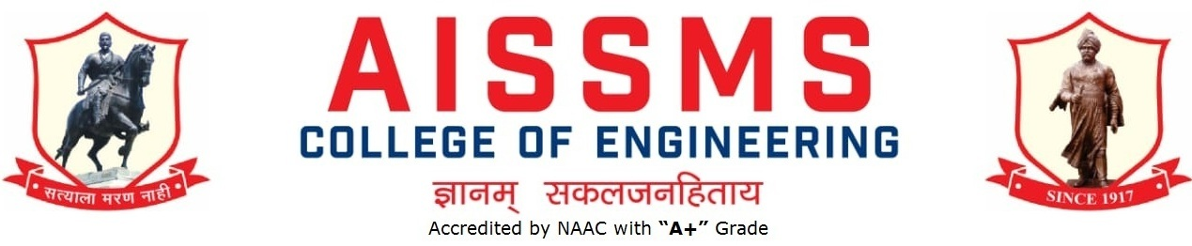

**TECHNICAL PROJECT HACKATHON AISSMSCOE PUNE**

**स्वयंसिद्ध टेक्निकल हॅकाथोन 2020**

**Rule Book for Swayamsiddha Hackathon**

1. The ideas should be from the mentioned sectors only. The sectors are as follows:
2. Organic Farming
3. Water Management
4. Energy Resources
5. Artisan, Industries and live hood
6. Basic Amenities
7. Education and training
8. Infrastructure
9. Women Empowerment
10. Problem should be self identified and should give technical solution.
11. Only unique ideas will be accepted. In case of copy or duplicate ideas, the idea as well as the team will be disqualified.
12. Maximum 5 members are allowed in a single team.
13. Multiple idea / solution to a problem(s) can be submitted by a single team .
14. Make sure the registered team name is unique.
15. Shortlisted participants will have to present the idea on the platform provided by the organizers.
16. The best shortlisted project idea will be asked for project implementation, after colleges reopen.
17. Participation E-Certificate will be awarded to all the participants.
18. No registration fees.
19. The copyrights of the implemented projects will remain with the respective team although; it can be implemented by the organizing institute (AISSMS COE) for any purpose.